CSIT314 Software Development Methodologies - Group Project

Sprint 3 - US42: View IDP category
Interior Design Platform - Platform Manager
All diagrams were drawn in draw.io. Open "US42 View IDP category.drawio" in this folder to edit them - each diagram is its own page in that file. The exported images are in the "diagrams" folder.

Assumptions
- The system is the Interior Design Platform from the project specification. Sprint 3 adds the Platform Manager's stories (log out and IDP categories, US40 - US45) and the Interior Designer's first IDP story (add a current IDP, US20).
- We follow B-C-E: the actor only talks to the boundary (page), the boundary only talks to the controller, and the controller works with the entity classes. There is one controller per use case.
- Only an active Platform Manager can use the IDP category pages: the account and its profile must both be Active and the profile must have the "Manage IDP categories" and "Generate reports" permissions. This is checked again from the database on every request with the US39 PlatformManagerLoginController.getAuthenticatedManager(). Someone not logged in goes to /manager/login; anyone else gets "Access unavailable" (HTTP 403).
- The manager opens a category from the IDP Categories list (US45) by clicking "View".
- The details page shows the name, the status badge, the description and every Active IDP that is grouped in the category (title, type and location), newest first. This lets the manager check that IDPs are grouped correctly.
- IDPs are added to a category by designers (US20). Suspended categories can still be viewed.
- The Update (US43) and Suspend (US44) buttons start from this page.

1. User story
Story ID | US42
User story | As a platform manager, I want to view IDP categories and the IDPs in them so that I can check whether IDPs are grouped correctly.
Actor | Platform Manager
Priority | Medium
Story points (estimate) | 2
Acceptance criteria | 1. Given I am on the IDP Categories page, each category has a "View" link.  2. Given I click "View", then I see the category's name, status and description.  3. The page lists every IDP in the category with its title, type and location.  4. Given the category has no IDPs, then I see "No IDPs are in this category yet".  5. Given the category doesn't exist, then I see "IDP category not found".
Tasks | T42.1 Write the use case description and draw the use case diagram  T42.2 Draw the B-C-E class diagram and the sequence diagram  T42.3 Draw the wireframes for the list, the details, no IDPs yet and not found  T42.4 Add the idp table (categoryId links an IDP to its category) to database/schema.sql  T42.5 Write the unit tests first (TDD) for IDPCategory.getIDPCategory(), IDP.getIDPsInCategory() and the page  T42.6 Code ViewIDPCategoryController and ViewIDPCategoryPage  T42.7 Code the viewIDPCategory.html template  T42.8 Run the test cases, fix bugs and push to the repo so the CI pipeline runs the unit tests

2. Use case diagram
The user story becomes one use case, UC42 View IDP category. The Platform Manager is the only actor.
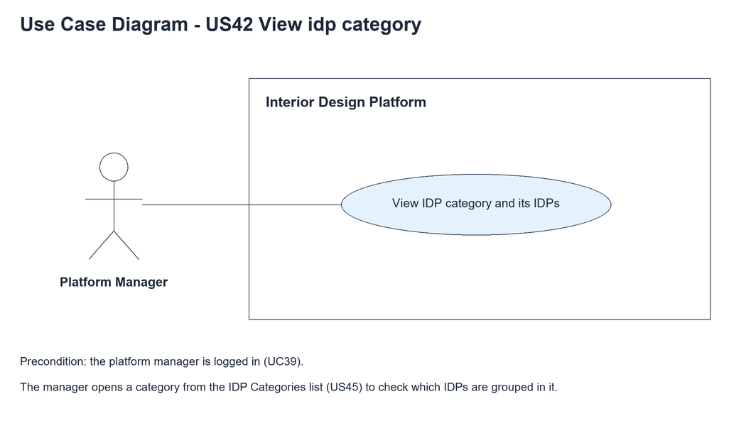
Figure 1: Use case diagram for US42 View IDP category

3. Use case description
Use case | UC42 View IDP category
Actor | Platform Manager
Brief description | The Platform Manager opens an IDP category to see its details and the IDPs grouped in it.
User story | US42: As a platform manager, I want to view IDP categories and the IDPs in them so that I can check whether IDPs are grouped correctly.
Preconditions | The Platform Manager is logged in (UC39).
Trigger | The Platform Manager clicks "View" next to a category on the IDP Categories page.
Basic flow | 1. The Platform Manager clicks "View" next to a category.  2. The system checks the manager's access.  3. The system loads the category.  4. The system loads the Active IDPs in the category.  5. The system shows the name, status, description and the list of IDPs.
Alternative flows | 3a. The category doesn't exist: the system shows "IDP category not found". The use case ends.  4a. There are no IDPs in the category: the system shows "No IDPs are in this category yet".
Postconditions | Nothing is changed (read only).

4. Wireframes
The wireframes were drawn in draw.io. They are low-fidelity: they show the layout and the flow, not the final colours. The orange numbers match the notes under each screen.

4a - Categories list
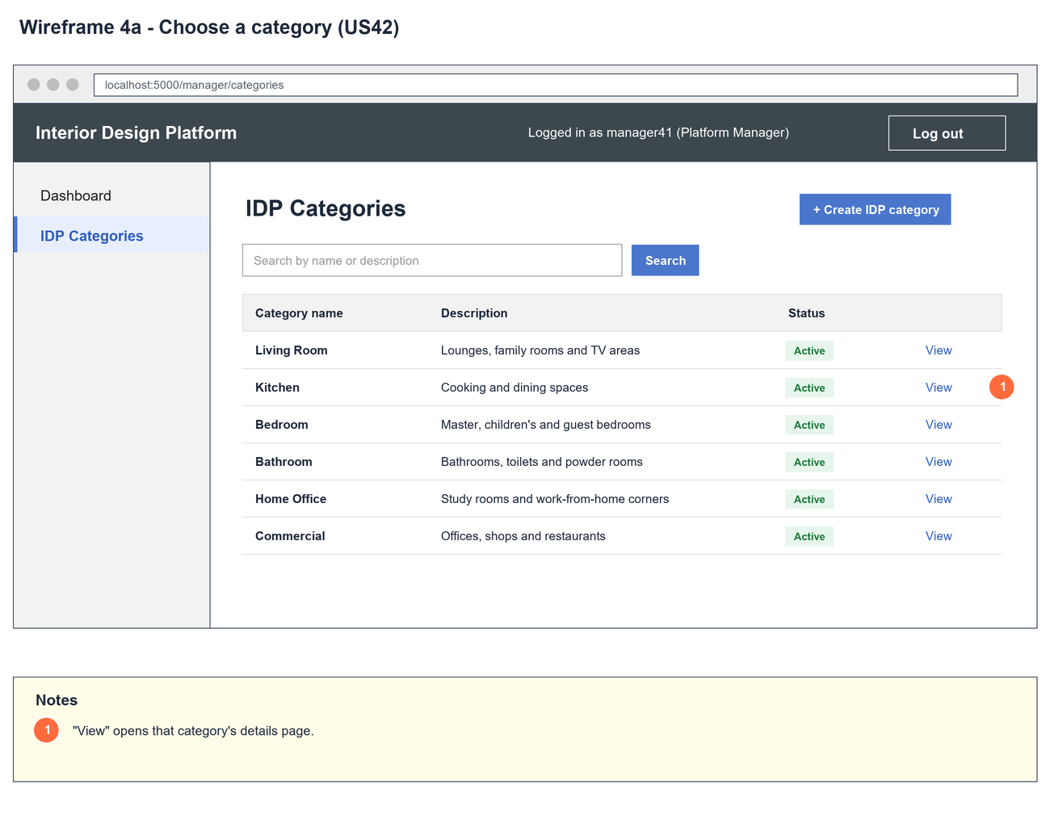
Figure 2: Wireframe 4a - Categories list (US42)

4b - Category details
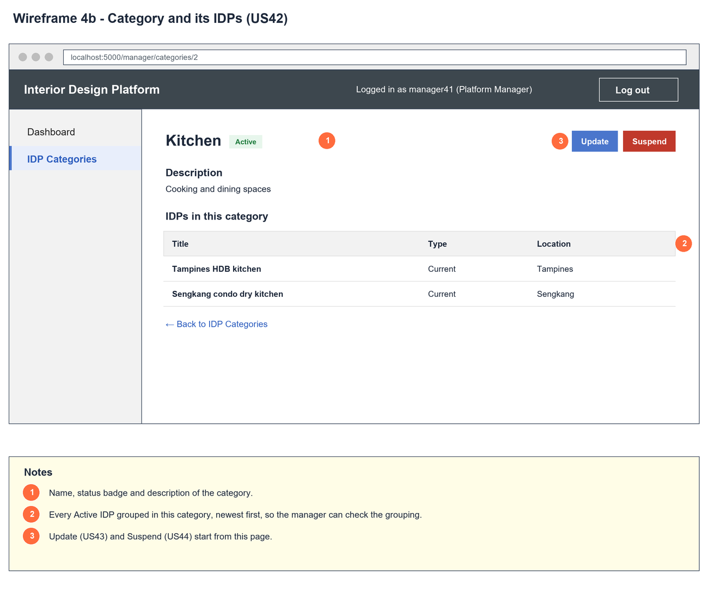
Figure 3: Wireframe 4b - Category details (US42)

4c - No IDPs yet
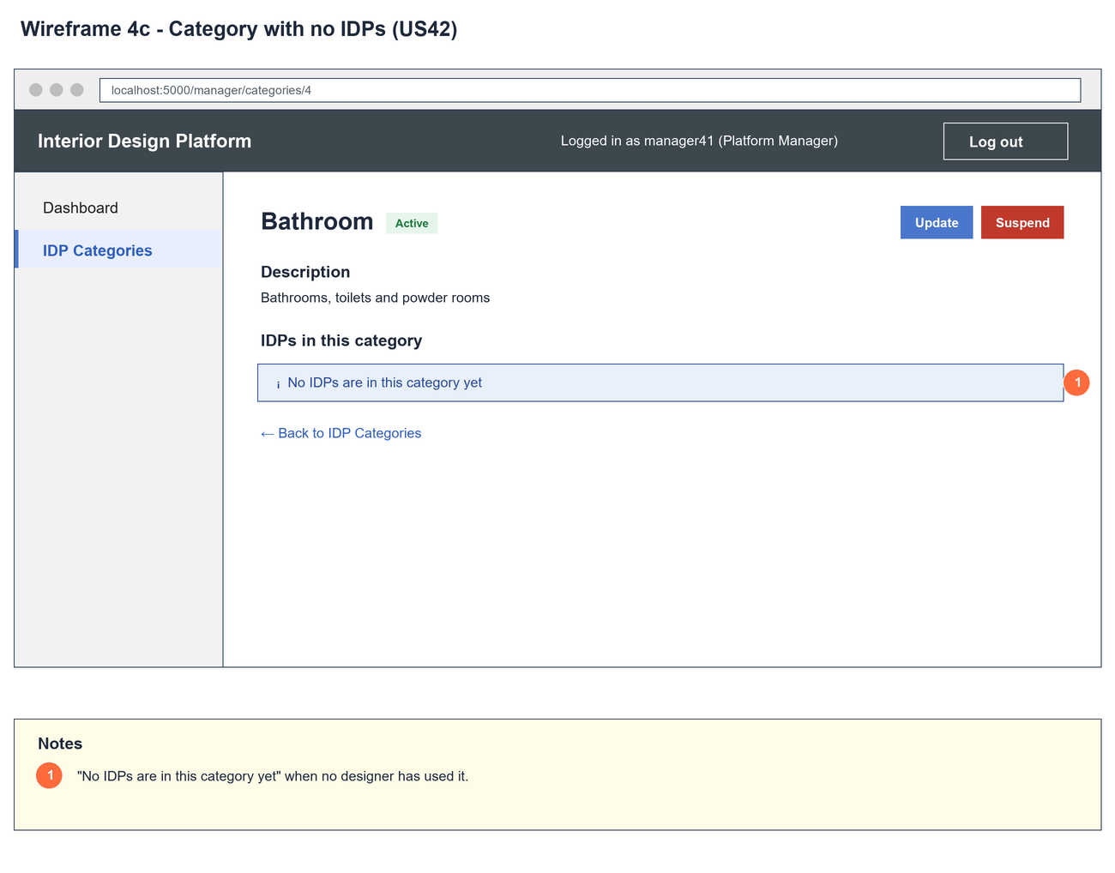
Figure 4: Wireframe 4c - No IDPs yet (US42)

4d - Category not found
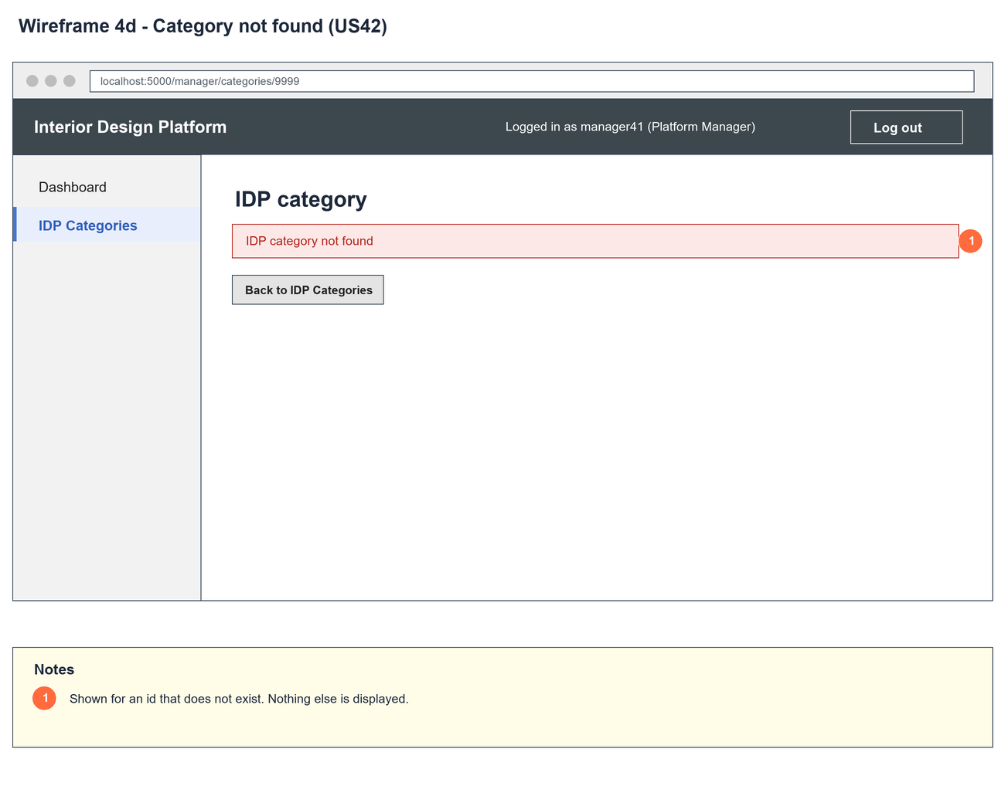
Figure 5: Wireframe 4d - Category not found (US42)

5. B-C-E class diagram
The solid line means the boundary calls the controller. The dashed lines mean the controller uses the other classes. Only the operations needed for this use case are shown, with the same names as the code.
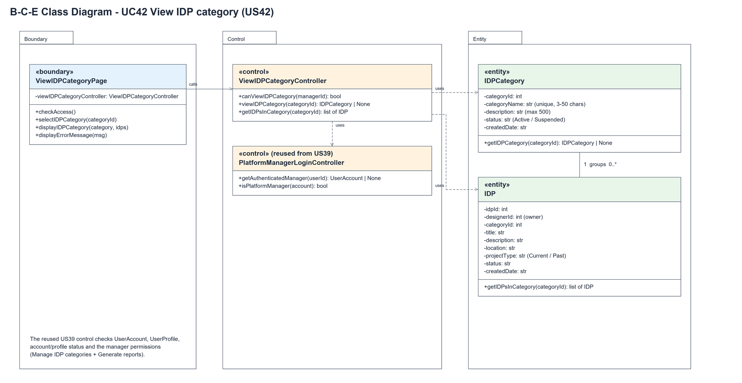
Figure 6: B-C-E class diagram for US42 View IDP category
Layer | Class | What it does
Boundary | ViewIDPCategoryPage | The category details page. selectIDPCategory() loads the category and its IDPs through the controller; displayIDPCategory() or displayErrorMessage() shows the result.
Control | ViewIDPCategoryController | Controller for UC42. canViewIDPCategory() checks access, viewIDPCategory() returns the category (or None), getIDPsInCategory() returns its IDPs.
Control | PlatformManagerLoginController (from US39) | getAuthenticatedManager() reloads the account and checks it is an active Platform Manager.
Entity | IDPCategory | getIDPCategory() returns one category or None.
Entity | IDP | One row of idp, owned by a designer and linked to one category. getIDPsInCategory() returns the Active IDPs in a category, newest first.

6. Sequence diagram
The sequence diagram follows UC42. After the access check (messages 2-5) the controller loads the category. The alt shows the details with the IDPs when the category exists, or "IDP category not found" when it doesn't.
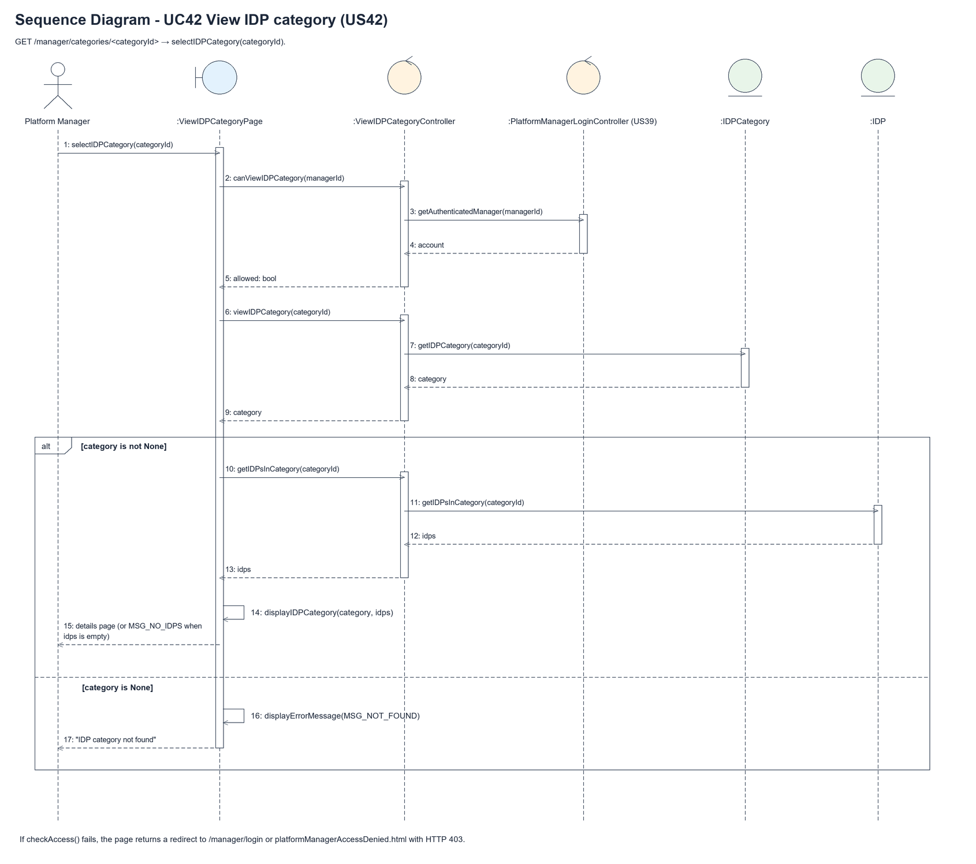
Figure 7: Sequence diagram for UC42 View IDP category

7. Test cases
Test data used below (same as database/seedData.py and the test files): user profiles User Admin (id 1), Interior Designer (id 2), Customer (id 3) and Platform Manager (id 4), all Active. User accounts admin01 / Admin@123 (User Admin) and cust001 / Cust@123 (Customer). The manager account manager42 / Manager@123 (Daniel Tan, Platform Manager profile) is made first with UC8. IDP categories are made in each test with UC41, e.g. Kitchen ("Cooking and dining spaces"), Bedroom and Office. The designer account designer42 / Design@123 (Interior Designer profile) adds IDPs with UC20, e.g. "Tampines HDB kitchen".

7a. System test cases (black box)
Equivalence partitioning and boundary value analysis were used to pick the test data. Fill in "Actual result" and "Pass/Fail" after running each test.
Test ID | Scenario | Prerequisites | Test steps | Test data | Expected result | Actual result | Pass / Fail
TC42.1 | View a category with IDPs | Kitchen has the IDP "Tampines HDB kitchen". | 1. Open IDP Categories  2. Click "View" next to Kitchen | Kitchen | Kitchen details: Active badge, description and "Tampines HDB kitchen" in the IDP list.
TC42.2 | Category with no IDPs | Bathroom has no IDPs. | 1. Click "View" next to Bathroom | Bathroom | "No IDPs are in this category yet".
TC42.3 | Only this category's IDPs | Kitchen and Bedroom each have one IDP. | 1. View Kitchen | - | Only the Kitchen IDP is listed.
TC42.4 | Category not found | Logged in as manager42. | 1. Open /manager/categories/9999 | categoryId 9999 | "IDP category not found" and a Back button.
TC42.5 | Suspended category | Kitchen is Suspended (US44). | 1. View Kitchen | - | Details shown with a Suspended badge and no Suspend button.
TC42.6 | Not a manager | Logged in as designer42. | 1. Open /manager/categories/1 | - | "Access unavailable" (HTTP 403).

7b. Unit test cases (for TDD)
These are written before the code (test-driven development) and run with pytest. They cover normal inputs, abnormal inputs and boundary values. Each one matches a test function in tests/test_us42_viewIDPCategory.py (UT42.n = test_ut42_n_...).
Test ID | Class and method | Input / setup | Expected output | Type | Pass / Fail
UT42.1 | IDPCategory.getIDPCategory() | Id of Kitchen | Kitchen with its description | Normal | Pass
UT42.2 | IDPCategory.getIDPCategory() | Id 9999 | Returns None | Abnormal | Pass
UT42.3 | IDP.getIDPsInCategory() | IDPs in Kitchen and Bedroom | Only the Kitchen IDP | Normal | Pass
UT42.4 | IDP.getIDPsInCategory() | Category with no IDPs | Empty list | Boundary | Pass
UT42.5 | ViewIDPCategoryController.viewIDPCategory() | Id of Kitchen | Kitchen | Normal | Pass
UT42.6 | ViewIDPCategoryController.viewIDPCategory() | Id 9999 | Returns None | Abnormal | Pass
UT42.7 | ViewIDPCategoryController.getIDPsInCategory() | Kitchen with one IDP | 1 IDP owned by designer42 | Normal | Pass
UT42.8 | ViewIDPCategoryController.canViewIDPCategory() | manager42, designer42 | True, false | Normal | Pass
UT42.9 | ViewIDPCategoryPage.selectIDPCategory() | GET the Kitchen page | Description, IDP title and Active badge shown | Normal | Pass
UT42.10 | ViewIDPCategoryPage.displayIDPCategory() | Category with no IDPs | "No IDPs are in this category yet" | Boundary | Pass
UT42.11 | ViewIDPCategoryPage.displayErrorMessage() | GET /manager/categories/9999 | "IDP category not found" | Abnormal | Pass
UT42.12 | IDP Categories list (US45 page) | GET /manager/categories | Has a link to the category details | Normal | Pass
UT42.13 | ViewIDPCategoryPage.checkAccess() | Not logged in | Redirects to /manager/login | Abnormal | Pass
UT42.14 | ViewIDPCategoryPage.checkAccess() | designer42 | HTTP 403 | Abnormal | Pass
UT42.15 | ViewIDPCategoryPage.checkAccess() | Manager suspended after logging in | HTTP 403 | Boundary | Pass

